Itgalpura, Rajanukunte, Bengaluru – 560064

**SCHOOL OF ENGINEERING**

A PROJECT REPORT ON

**MOBILE CHARGING ON COIN INSERTION**

SUBMITTED IN PARTIAL FULFILLMENT OF THE REQUIREMENT FOR THE COURSE

INNOVATIVE PROJECT – ARDUINO USING EMBEDDED C (CSE1002)

SUBMITTED BY

GROUP: IPC – 79

|  |  |
| --- | --- |
| **STUDENT NAME** | **ROLL NUMBER** |
| V HARSHINI | 20211CSE0408 |
| SAMARTH B DEVARAMANI | 20211CSE0404 |
| GAURAV H | 20211CSD0125 |
| SAMUEL R | 20211COM0037 |
| PRAVEEN KUMAR G S | 20211COM0038 |
| SANDEEP IYAGAR | 20211PET0018 |

UNDER THE SUPERVISION OF

GUIDE NAME: Ms. STERLIN MINISH T N

DESIGNATION: ASSISTANT PROFESSOR

DEPARTMENT: COMPUTER SCIENCE AND ENGINEERING

**ABSTRACT**

Mobile-phones have become an essential gadget for communication as well as our day-to-day life. Hence, charging the mobile phones have become a greater task. In this project, we are trying to design a mobile battery charger on coin insertion. As usage of mobile phones have been increasing day by day, it thus becomes necessary for us to charge the device from time-to-time. This is where public charging comes into the play. Excessive usage of mobile phones in public places could drain the battery, and to keep using the device, they can be re-charged through these public mobile charger by inserting a coin. Once the coin has been inserted, the coin is recognized, and then the user can charge their device through one of the adapters that come along with the system. The mentioned system can be implemented in public places like railway stations, airports, bus stops, hospitals, malls, cafeterias, etc. to avail these services.

**HARDWARE**

The inputs to the system are provided via the keypad matrix and the coin insertion module, while the outputs can be observed on the LCD and the mobile charging adapter. The microcontroller does the processing, and the power supply unit makes sure that each one performs perfectly by providing the adapter with sufficient current and voltage.

* **Microcontroller:**

The system uses the Arduino UNO R3 Microcontroller. It is our system’s brain. The UNO consistently checks if any coin is inputted into the system by reading the coin insertion module’s coin pin. After detecting the coins inputted by the user, it calculates the amount required for charging and then turns on the mobile charging unit via a relay module for the exact time for which the user inserted the coins.

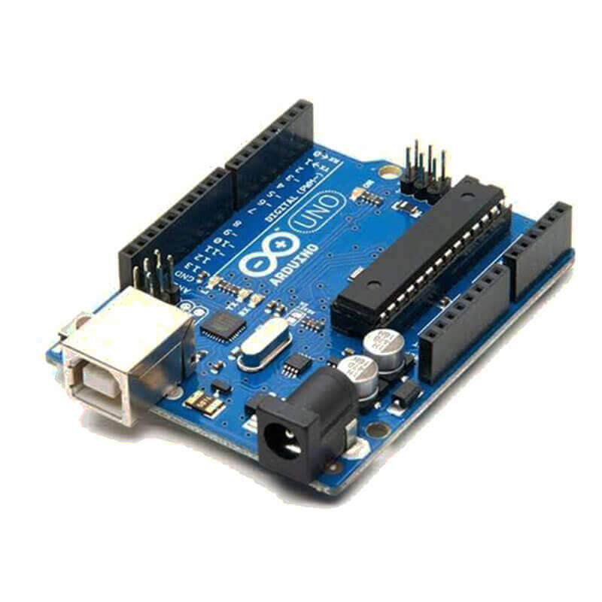

**Fig. 1**

* **Coin Insertion Module:**

The coin Insertion module is the heart of the proposed system. The user interacts with this machine to input the desired number of coins. It is a multi-coin acceptor that can accept up to 6 kinds of different coins simultaneously. This type of coin selector is widely used in the Vending machine, Arcade Game, Message chair, and other self–management systems. To identify coins it is based on material Weight and Size. We have programmed it to take only two coins: INR 5 and INR 10. If the user inputs any other coin or wants to input a fake coin, it will be returned to them. It works on 12V DC and requires 65mA for optimal working.

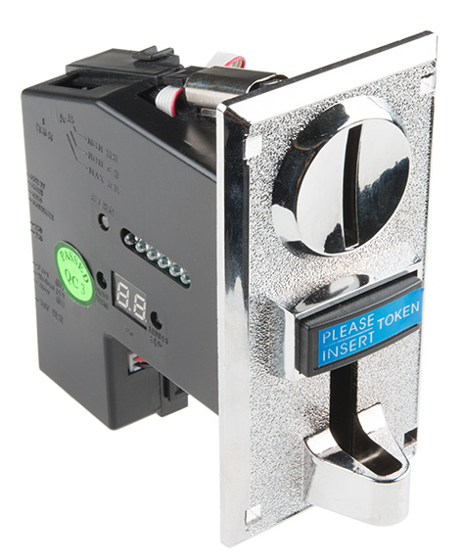

**Fig. 2**

* **Liquid Crystal Display:**

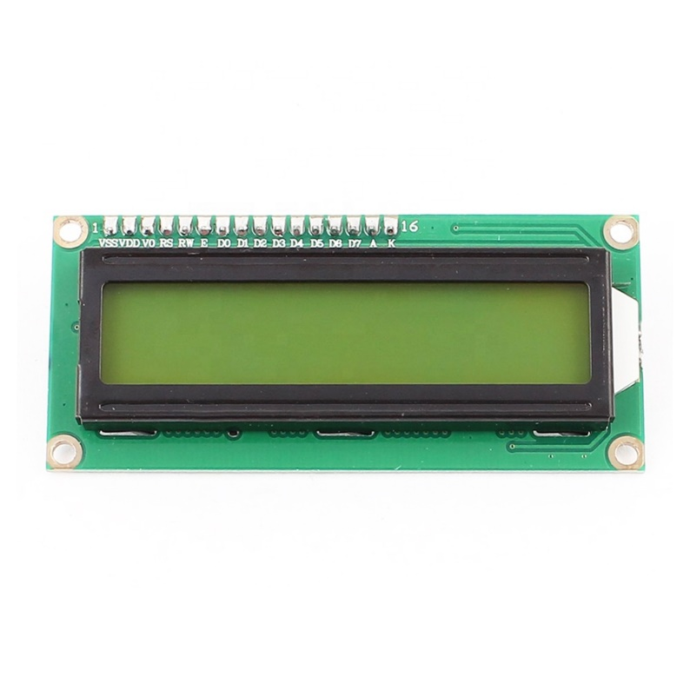The LCD interacts with the user visually. It displays a welcome message and guides the user on how to operate the system properly. The system uses a 16x2 liquid crystal display for interacting with the user.

**Fig. 4**

* **Mobile Charging Adapter:**

This unit is the most important one. It charges the users’ smartphone. It draws power from the mainline (230V AC) and converts it to 5V DC. It has an inbuilt transformer, rectifier and filter. A relay is used to switch ON the charging when coins are inserted and switches OFF when the allotted time for charging has passed.

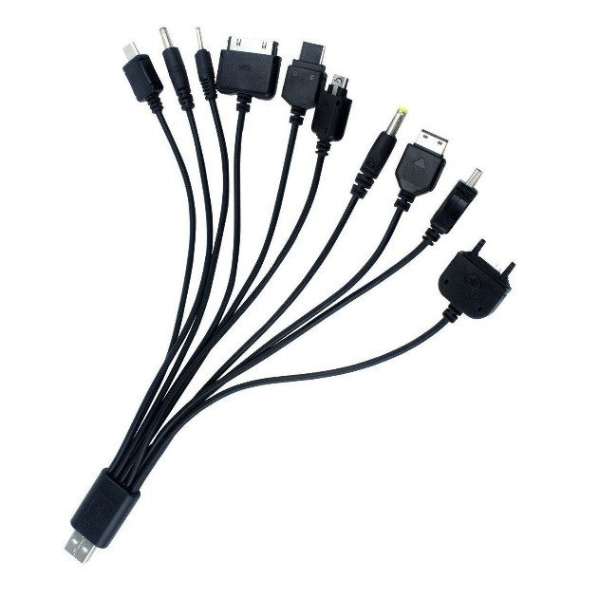

**Fig. 5**

The purpose of using an adapter with cable is that the user may not always have a data cable with himself, and so we have included it in our machine. We have inculcated a type C charger pin considering it is the most common one nowadays. Different types of pins can also be provided in different machines on user demands.

* **Relay Module:**

The Relay Module is used to control the charging of the user’s smartphone when connected to the system. Hence, it is necessary to include it in hardware requirements. The relay is controlled and powered by the microcontroller.

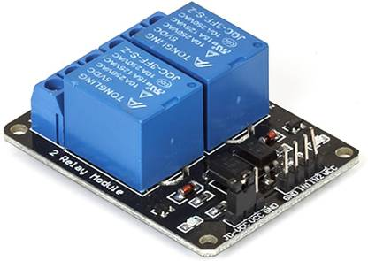

**Fig. 6**

* **Power Supply:**

Now the system needs the power to work. It is provided by the power supply to other modules as shown in Fig. 7. We need to provide power to the microcontroller, coin insertion module and mobile charging unit. This power is received from the mainline (230V AC) and converted to a regulated 12V DC supply via AC to DC converter. The power to relay and LCD module is provided by the microcontroller itself when connected.

6 V

Relay Module

5 V

LCD Module

12 V DC

Microcontroller

12 V DC

Coin Insertion Module

12 V DC

Regulated Supply

AC – DC

Converter

250 V AC

Supply Line

5 V

Mobile Charging Adapter

**SOFTWARE**

The proposed system is a Real-Time system and is a combination of hardware and software. In the previous section, all the required hardware and its functions were described. In this section, the software used to write the source code of the system will be explained. The system uses Arduino UNO R3 Microcontroller, and hence Arduino IDE is used to write the source code.

**Arduino IDE Software**:

This open-source Arduino Software (IDE) makes easier to write code and upload it to the board. In this case, we have used the Arduino UNO R3 Microcontroller. This software can also be used with any Arduino board.

**BLOCK DIAGRAM**

There are six blocks in the block diagram of the proposed system: Power Supply, Coin Insertion Module, Microcontroller, Keypad, Liquid Crystal Display and Mobile Charging Adapter. The various functions of each block in the complete system is explained in the latter part. In a nutshell, the system will charge the users’ smartphone when they enter the desired number of coins in the machine.

Power Supply

Arduino UNO

Microcontroller

Coin Insertion Module

Mobile Charging Adapter

Keypad

Liquid Screen Display (LCD)

**WORKING**

The system begins with the LCD asking the user to insert the coin. Any other coin the user inserts will not be accepted by the system and is returned to the user. Once the coin is inserted, its physical properties are checked. If the conditions for the coin being real and valid is verified right, the device beings charging. Otherwise, the coin is returned to the user, asking the user to insert a coin. Once the verification is done, the coin insertion module sends a pulse to the microcontroller, which in turn sends a pulse to the 6V relay module. The relay module controls the flow of electricity to charge the device. It allows the electricity to flow through to the load as long as the timer has been set. The amount of time the device would be charged for will be displayed to the user on the LCD. For 5 rupees, the user will be allotted a 5-minute time slot to charge their device.

After the charging time has elapsed, the controller automatically resets the device for a new charge.

**RESULT**

The proposed system is programmed in Arduino IDE, and it comprises Arduino UNO R3 Microcontroller, 16x2 Liquid Crystal Display, I2C Module, 4x4 Keypad Matrix, DC 5V Single Channel Relay, DC 12V Adapter, and Coin Insertion Module. Firstly, welcome message is displayed on the LCD by using the microcontroller. Then, the user is asked to enter ‘1’ to move to the next step, which involves insertion of coins. As the user keeps inserting the coins, the microcontroller keeps updating the input amount and also displays it on the LCD. After, the coin is accepted, microcontroller sends HIGH signal to the relay module, and the relay changes it state from NO to NC and then the user is asked to connect the adapter to the mainline. This is how Mobile phone starts Charging for allotted time slots.

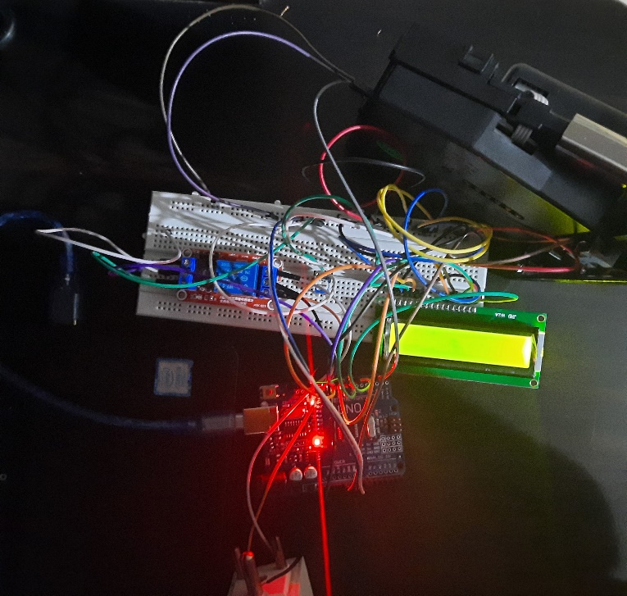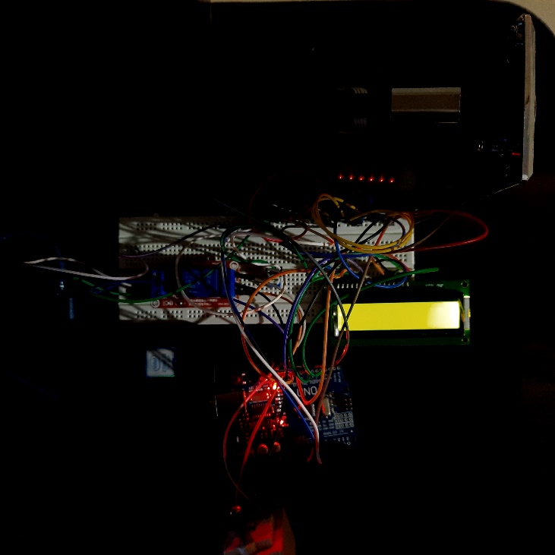

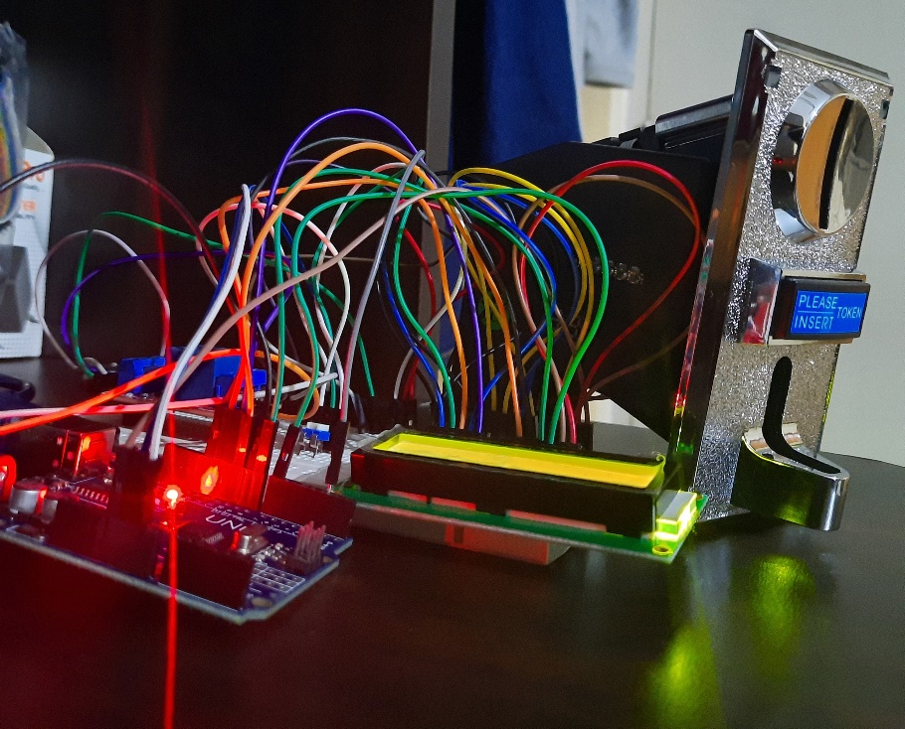

**CHALLENGES FACED**

* The main component of our project is the coin insertion module. Finding this module was nearly impossible, thus, it was decided to order the component online and set it up for the final build.
* Another problem faced by our team was, connecting the components. The battery nearly short-circuited while performing a test run on the system.
* Even the reference materials which had the circuit diagram couldn’t help us have the system work. Despite us following the same connections, the system seemed to be lacking something. All the components receive power supply and light up, but they don’t seem to respond to the coin inserted.

**CONCLUSION**

A method of charging mobile batteries of particular manufacture has been designed and developed whenever required. This project is beneficial in today’s life. Nowadays, communication is vital, so every person has a smartphone, but they do not carry a charger with them every time. When they are going for extended travel, they might forget to carry a phone charger. This project is used to help the people by building a coin-based charger. Also, nowadays, this kind of project is beneficial because of the extensive internet and smartphones usage. Conventional grid power is used for mobile charging; hence the project is low cost. In the literature survey, we have cited that many other peoples have provided an approach to this project, but they are powering their system with solar power, which makes the complete system less compatible, more maintenance is needed, power issue during night, more costly overall and not feasible over a long run. Our system uses the main supply, which can be produced from a renewable power plant, instead of using the solar panel which makes it complicated and less productive over a long-term period.